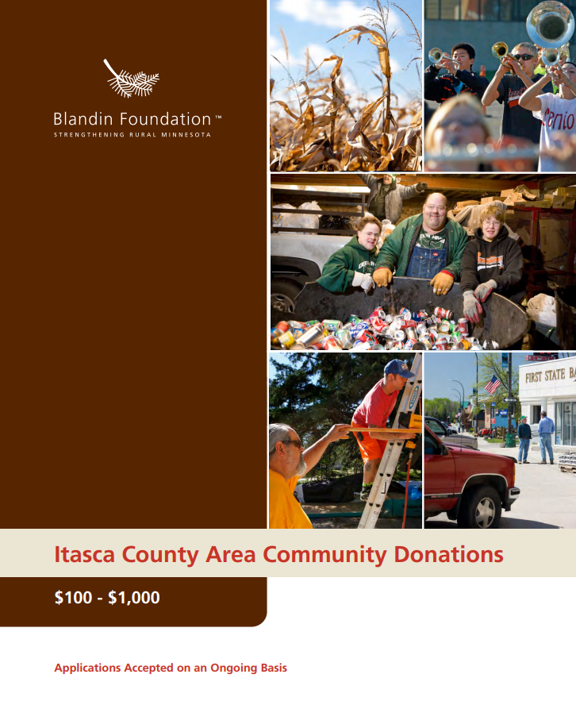

Grants $1,001 to $10,000
If you haven’t already, please visit our website to check your project’s fit with our eligibility guidelines and areas of focus. Please email all grant applications to grants@blandinfoundation.org. Supporting information may be mailed separately or scanned and sent as attachments. If you do not receive acknowledgment of your application in 2-3 business days, please call us at 218-326-0523.

Organization Information
______________________________________ ______________________________________
Name of organization Name on articles of incorporation, if different _________________________ __________________________ ________________________________
Address City, State, Zip Employer Identification Number (EIN)
__________________________ __________________________ _______________________________
Phone Fax Website
_________________________________ ___________________ _____________ ___________________

Name of Executive Director, CEO, Title Phone E-mail
Board Chair, or Lead Organizer

_________________________________ ___________________ _____________ ___________________
Name of contact person regarding Title Phone E-mail
this application

Is your organization an IRS 501(c)(3) nonprofit? ☐ Yes ☐ No
If no, is your organization a public agency, tribal government entity, or unit of government?
☐ Yes ☐ No
If no, list name and address of fiscal agent, including EIN number: ___________________________________________ ________________________________
EIN Number

If working through a fiscal agent, please attach an email or letter confirming they have agreed to be fiscal agent for your organization.

Proposal Summary
Duration of project: ____________________________ to ______________________________
Please give a 2-3 sentence summary of your proposal:

Please give a 1-2 sentence summary of the geographic area your proposal will serve:

Please give a 1-2 sentence summary of how your board and staff are representative of the population you serve.

Budget Summary
Fiscal Year of Organization or Project: ____________________ to ______________________
Total project budget: $
Total dollar amount requested of Blandin Foundation: $
Total annual budget (organization, division, or program): $

Signature
_____________________________________________________________________________________ Name of CEO/Executive Director or Board Chair
_____________________________________________________________________________________Signature (scanned/electronic signature acceptable)

