Blandin Broadband Communities Program
Initial Steering Committee Meeting

Outcomes
By the end of this session, we will have…
- Understand our role as Steering Team Members
- Come to know our fellow team members and their leadership styles
- Identified connections we bring to our group and the role that we will play
- Identified who needs to be engaged in the BBC planning process
- Identified how we are going to have a successful Vision Meeting

Agenda
0:00 |  | Welcome  Community Representative
0:05 |  | Welcome and Program Overview/Role of the Steering Team –  Bernadine Joselyn, Blandin Foundation
0:15 |  | Steering Team Introductions  Understanding the Leadership Styles of our Coalition  Uncovering Our Community Connections
0:45 |  | Intro to the Blandin Broadband Communities Program and the Intelligent Community Framework  Bill Coleman, Blandin Community Broadband Coach
1:05 |  | The Vision & Brainstorm Meetings: Dates, Logistics and Invitations  Community Representative and Blandin Team
1:40 |  | The Blandin Team, Support and Resources  Mary Magnuson, Blandin Foundation
1:50 |  | Next Steps and Final Discussion
2:00 |  | Adjourn

This packet contains:
Personal Style Compass | Vision Invite Sheet | Draft Vision invitation language
Draft Press release

Blandin Team

Primary Contact:
Bill Coleman, Community Technology Advisors
651-491-2551
bill@communitytechnologyadvisors.com

Primary Grants Contact:
Mary Magnuson, Blandin Foundation
218-327-8738 (list of helpful links)
memagnuson@blandinfoundation.org
Bernadine Joselyn, Blandin Foundation
Director, Public Policy and Engagement
218-327-8728
brjoselyn@blandinfoundation.org

Personal Style Compass
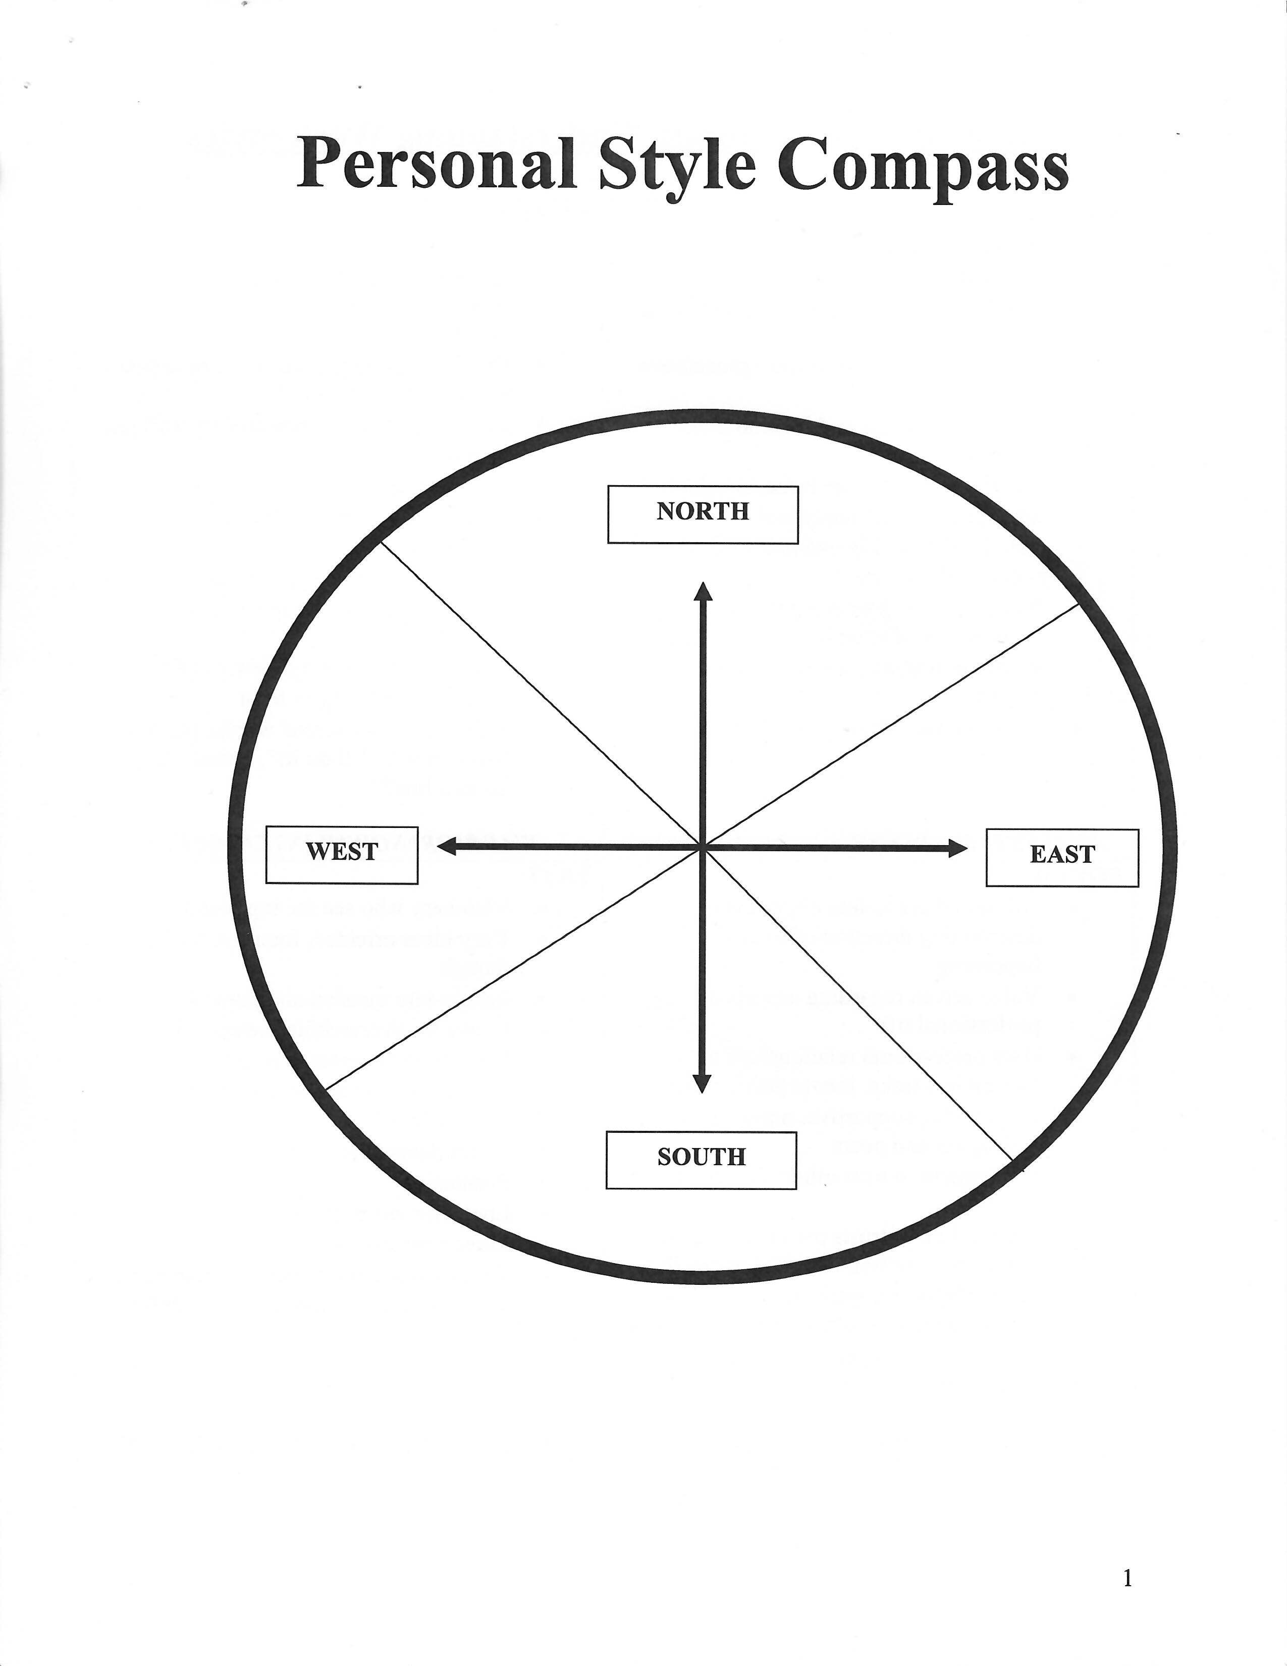
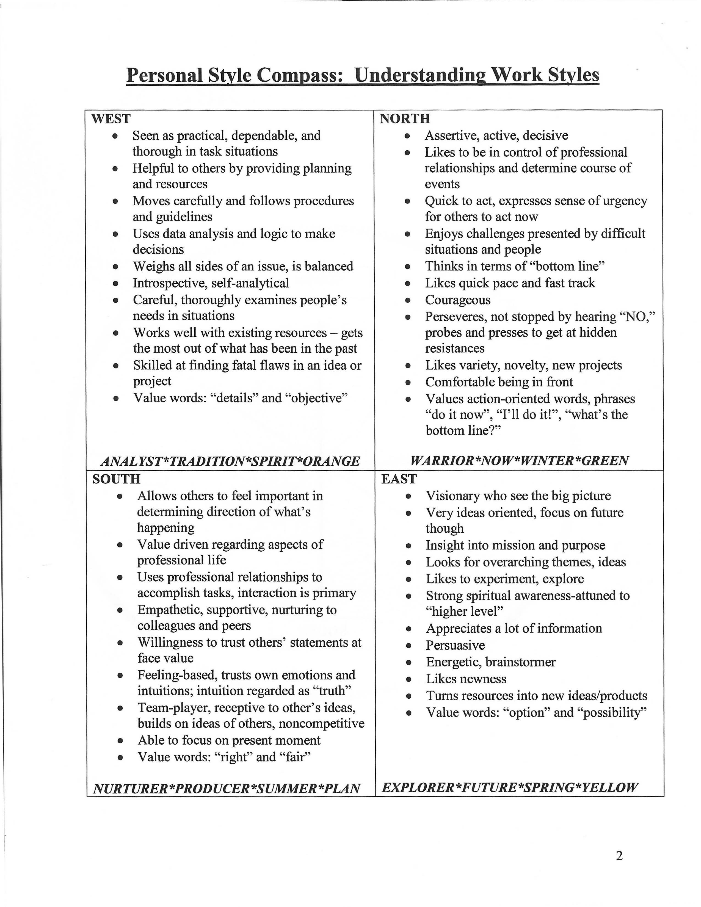
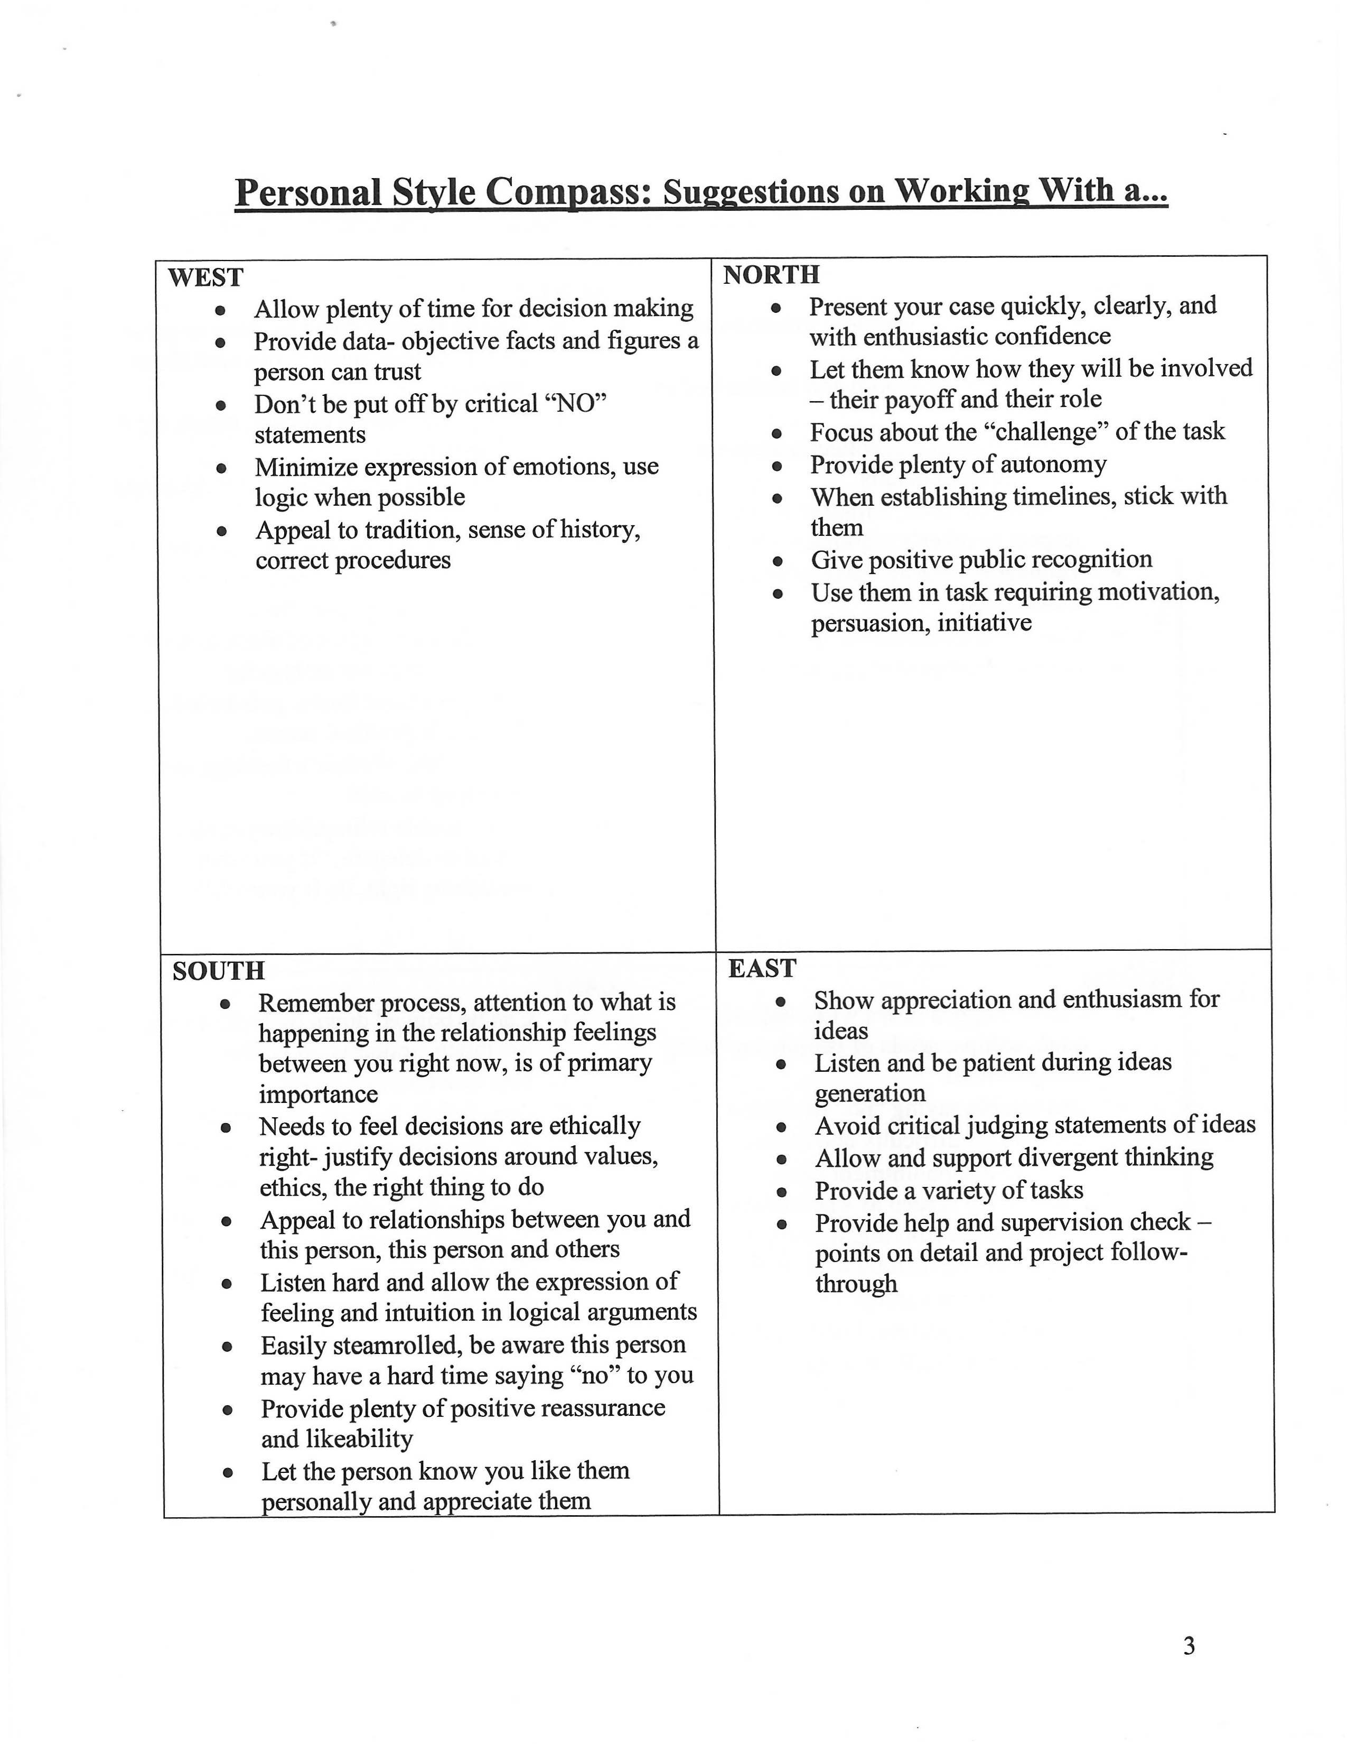
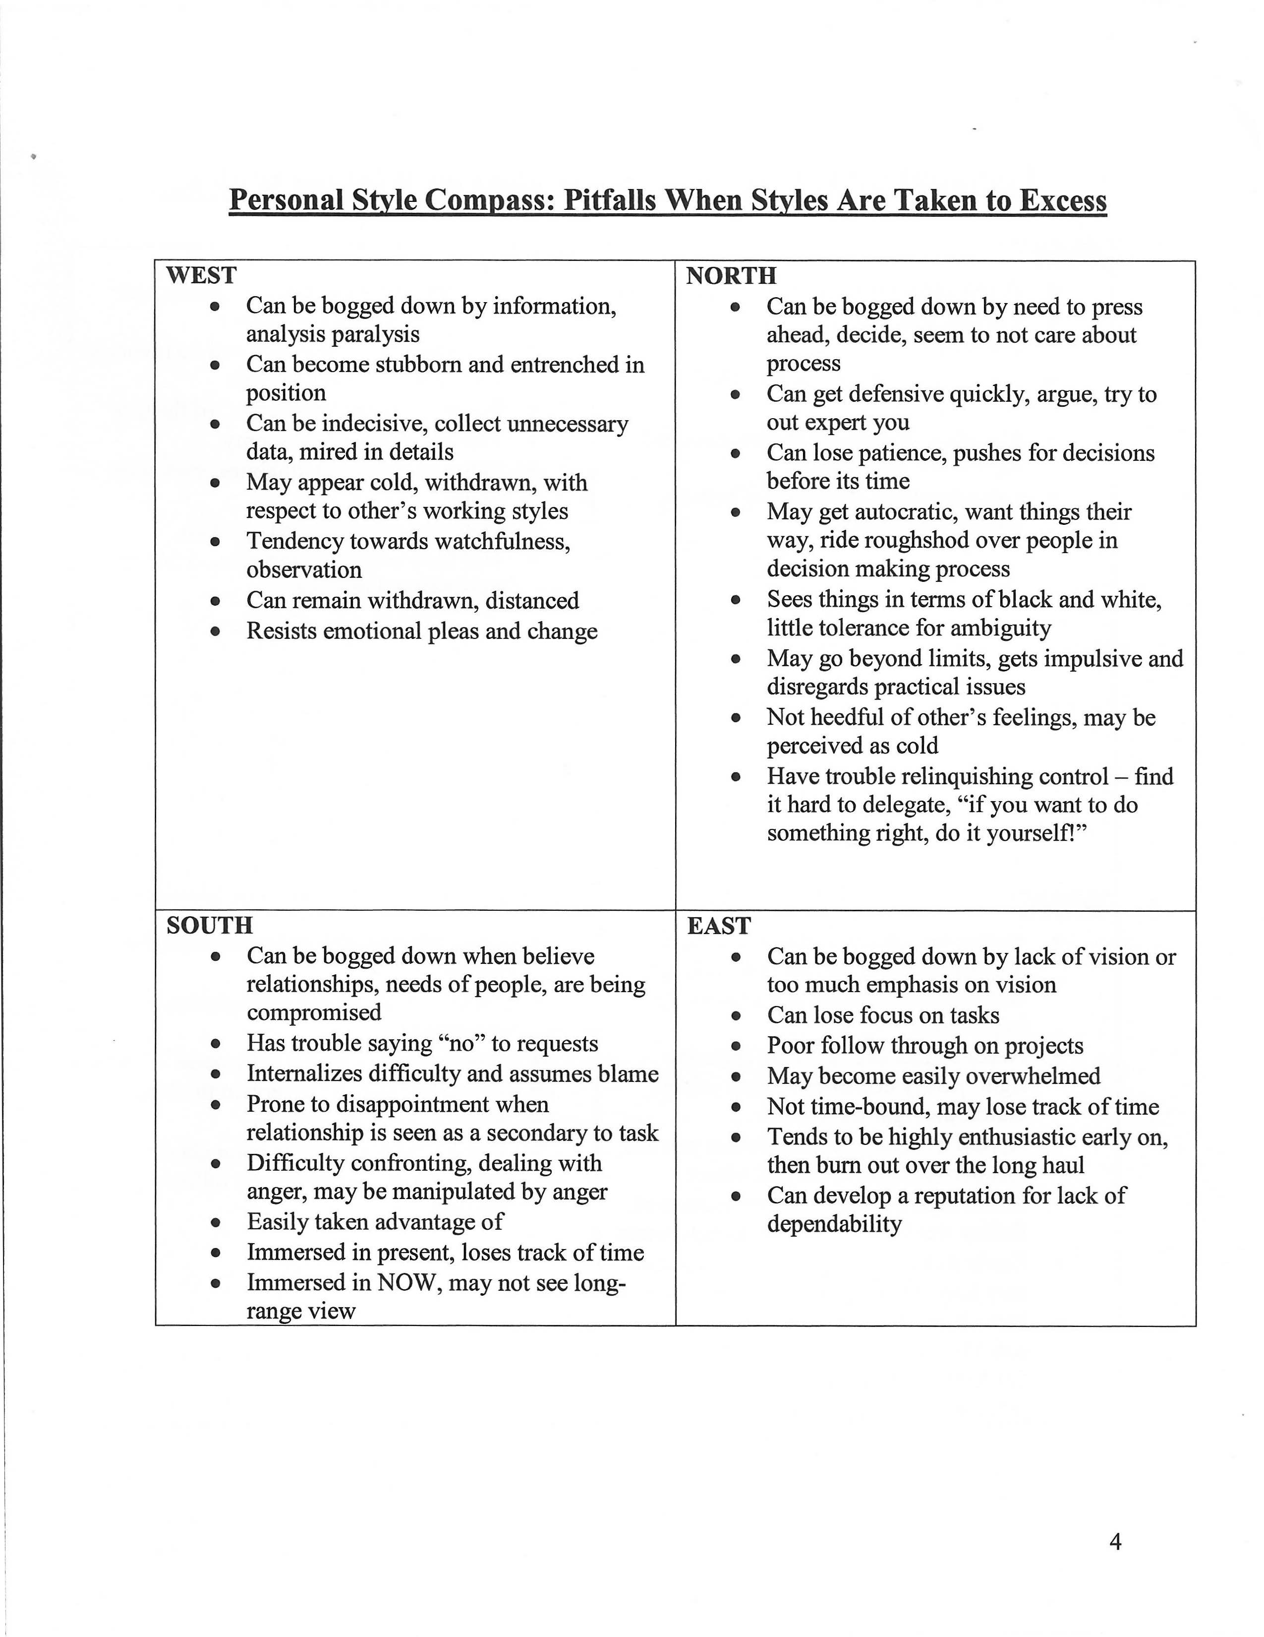

My working styles is:

Gifts that I can bring to our effort include:

Special knowledge that I have:

Connection that I can bring to our efforts:

Vision Invite Sheet
Creating a Successful Vision Meeting
“Getting the Right People in the Room”

Group | Key Individual | Who Will Contact? | Notes
Education
K-12
Private
College
Government
Local
County
Region
Business
Chamber
Key businesses
Tech businesses
Health Systems
Key Audiences
Older adults
Youth
New Americans
People with Disabilities
Job Programs
Veterans
Logistics
Facility
Refreshments
Media/Newspaper
Social Media/Web

Draft Vision invitation language

Draft Email Invitation to Blandin Broadband Community Vision Meeting

[Insert Greeting],
Vibrant and smart rural communities are connected communities. Abundant and robust access to the Internet, and the skills necessary to take full advantage of this access, are essential as [insert community name] seeks to compete and thrive in an ever more connected world.
We are excited to announce that we have been selected as a Blandin Broadband Community. This program will give us access to coaching, planning assistance and a chance to obtain financial resources that will positively affect our community. We need your voice in this process that is just getting underway.
This is about more than broadband. It is about our workforce, digital inclusion, innovation, sustainability and marketing. It is about our community as a whole and individual organizations and people. You don’t have to be a techie to be a contributor to our initiative.
[This coming/next] [insert day] our community has the opportunity to shape and pursue our technology goals by identifying our existing strengths/gaps and developing projects to move us forward. Come add your voice as we build the path to a highly-connected [insert community name].
WHEN:
WHERE: via zoom
RSVP:

We hope to see you there!

Draft Script for BBC Phone Conversations
Goal: Build Will. Audience should already know that broadband access and use is beneficial for your community. Help them see potential solutions and how they can help build toward it.

Advice:
1) Personalize the concern by linking it to something observable in your community. How do you know that this is a legitimate community concern? Concern emphasizes the problem that needs solving. You can also use “focus” if concern sounds too negative.
2) If you have a specific example/solution you can give from your community – use it! If not, share a solution from another rural MN community and past BBC.
………..

Hi, I wanted to reach out to you about some exciting work happening in our community around Internet access and use. (If “access and use” sounds too formal, replace with something more tangible like “exciting work to get more people and places hooked up to and using the Internet and all that it offers.” )
As the world becomes more connected, it’s important that [City/County] does everything we can to make sure our community doesn’t fall behind. You might have seen in the paper that [City/County] was named a Blandin Broadband Community and we now have the chance to develop a strategy and a series of projects that help move our community into the future, with help of up to $100,000 in grant dollars.

*Select one topical paragraph based on knowledge of your contact’s community and personal interests

For example, we know from {past community conversations, research, inquiries} that our schools are a priority for [City/County] residents. As schools learn how to best integrate technology into the classrooms, we also need to prepare our young people for careers where knowledge of technology is vital. Fond du Lac, a past Blandin Broadband Community, held an application development camp to introduce students to computer programming and also carried out a 1-to-1 mobile device program in the schools.
--
For example, we know from {past community conversations, research, inquiries} that healthcare is critically important to [City/County] residents. In our rural community, it’s not always easy or possible to make the drive to the nearest clinic or hospital. Kanabec County, a past Blandin Broadband Community, supported a partnership that used telehealth technology to provide pre-surgical patient education.
--
For example, we know from {past community conversations, research, inquiries} that the strength of our local business community is a primary concern for [City/County] residents. Our businesses are a cornerstone of our economy and it’s important we offer the resources and training they need to stay competitive. Itasca County, a past Blandin Broadband Community, focused all their broadband efforts on their local business community by creating a process where businesses worked with a consultant to assess how they were currently utilizing the Internet to promote and run their business. Those businesses were then able to access funds and training to enhance their knowledge based on recommendations.
--
For example, we know from {past community conversations, research, inquiries} that connecting all generations is a primary concern for [City/County] residents. Seniors in our community want to stay connected – to what’s going on in [City/County] and with their families. Lake County, a past Blandin Broadband Community, has developed a number of ways to get seniors connected. One was classes that brought together high school seniors and senior citizens to learn various things, like how to Skype with family, how to search for, and buy, items they need online. All things that can enhance seniors’ quality of life by keeping them connected to the people they care about and the information and things they need.
--
The Ask
And this is just one example. Projects could focus on healthcare, education, local business, seniors in our community, or any mix of them! We’re bringing together our community partners figure out our community’s priorities and we want you to be there. Our community visioning meeting is [time/place]. We need you to participate! Can we count on you to be there?

Draft Press release
[Organization Logo]

FOR IMMEDIATE RELEASE

Community invited to attend planning meeting for future Internet projects

[CITY], Minn. (DATE) – [Calling organization] invites the public to attend our Blandin Broadband Community Vision meeting where priorities will be determined and projects developed to improve Internet access and use in [City/County].

[City/County] was named one of six new Blandin Broadband Communities, a program that provides planning, technical and financial support to communities that demonstrate the determination to bring the benefits of a broadband-enabled economy to their communities. These four communities will have access to a special grant fund, but projects will have to meet Blandin Foundation standards in order to be funded.

All interested community members can join a Zoom meeting at [date/time] to help identify our community’s strengths and gaps, brainstorm project ideas and prioritize potential projects. Cross-sector and collaborative efforts will be a priority. Once projects emerge, our [City/County] non-profits, schools and governments will have the opportunity to apply for up to $100,000 in total grant funding over two years.

{Add a quote about the value of the program and the excitement to get the community involved}

RSVP to [contact] at [number/email] by [date].

###

*Add background info on the organization or recent broadband efforts in your community.

Media contact
[Add information]

